EXERCISE 1 : CONTROL STRUCTURES

SCENARIO 1:
The bank wants to apply a discount to loan interest rates for customers above 60 years old.
CODE:
BEGIN
FOR cust_rec IN (
SELECT c.CustomerID, l.LoanID
FROM Customers c
JOIN Loans l ON c.CustomerID = l.CustomerID
WHERE MONTHS_BETWEEN(SYSDATE, c.DOB) / 12 > 60
) LOOP
UPDATE Loans
SET InterestRate = InterestRate - 1
WHERE LoanID = cust_rec.LoanID;
END LOOP;
COMMIT;
END;
SELECT * FROM Loans;
OUTPUT:
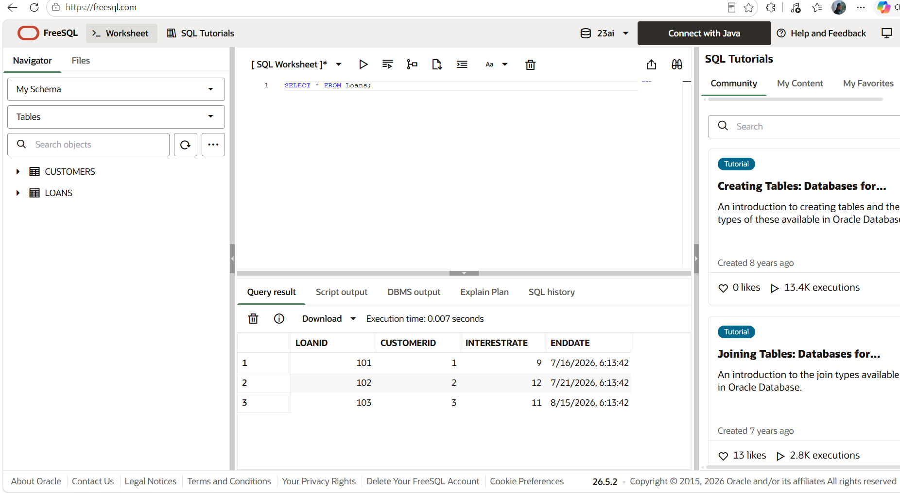

SCENARIO 2:
A customer can be promoted to VIP status based on their balance.
CODE:
BEGIN
FOR cust_rec IN (
SELECT CustomerID
FROM Customers
WHERE Balance > 10000
) LOOP
UPDATE Customers
SET IsVIP = 'Y'
WHERE CustomerID = cust_rec.CustomerID;
END LOOP;
COMMIT;
END;
/
SELECT * FROM Customers WHERE IsVIP='Y';

OUTPUT
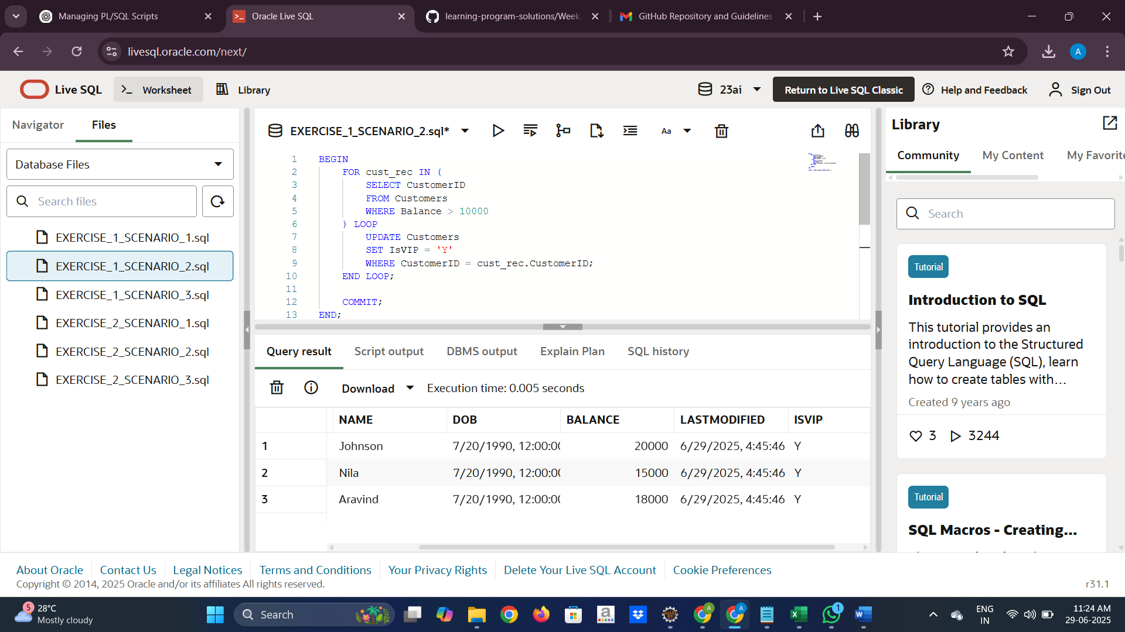

SCENARIO 3:
The bank wants to send reminders to customers whose loans are due within the next 30 days.
CODE:
BEGIN
FOR rec IN (
SELECT c.Name, l.LoanID, l.EndDate
FROM Loans l
JOIN Customers c ON c.CustomerID = l.CustomerID
WHERE l.EndDate BETWEEN SYSDATE AND SYSDATE + 30
) LOOP
DBMS_OUTPUT.PUT_LINE('Reminder: ' || rec.Name || ', your loan is due on ' || TO_CHAR(rec.EndDate, 'DD-MON-YYYY'));
END LOOP;
END;

OUTPUT:
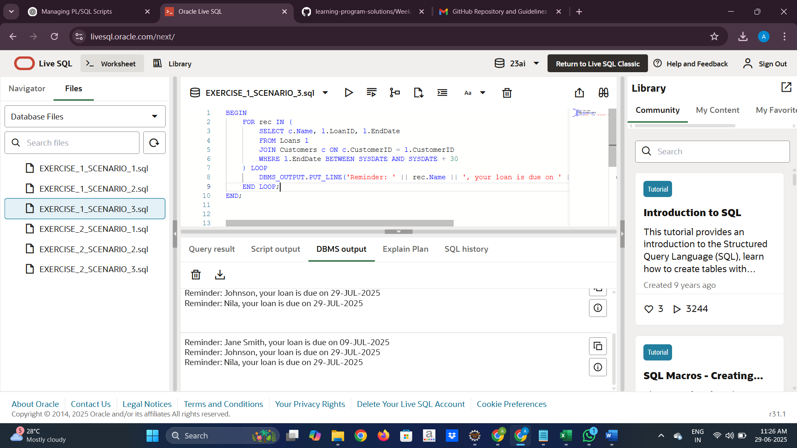

EXERCISE 3: STORED PROCEDURES

SCENARIO 1:
The bank needs to process monthly interest for all savings accounts.
CODE:
CREATE OR REPLACE PROCEDURE ProcessMonthlyInterest IS
BEGIN
UPDATE Accounts
SET Balance = Balance + (Balance * 0.01),
LastModified = SYSDATE
WHERE AccountType = 'Savings';
COMMIT;
END;
/
SELECT * FROM Accounts WHERE AccountType='Savings';

OUTPUT:
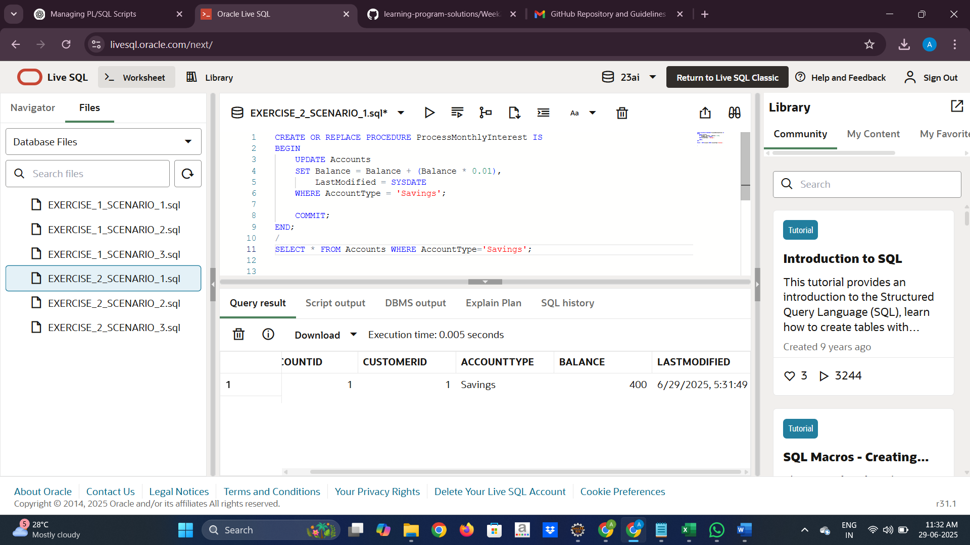

SCENARIO 2:
The bank wants to implement a bonus scheme for employees based on their performance.
CODE:
CREATE OR REPLACE PROCEDURE UpdateEmployeeBonus(
p_department IN VARCHAR2,
p_bonus_percent IN NUMBER
)
IS
BEGIN
UPDATE Employees
SET Salary = Salary + (Salary * (p_bonus_percent / 100))
WHERE Department = p_department;
COMMIT;
END;
/
BEGIN
UpdateEmployeeBonus('HR', 10);
END;
/
SELECT EmployeeID, Name, Department, Salary
FROM Employees
WHERE Department = 'HR';

OUTPUT:
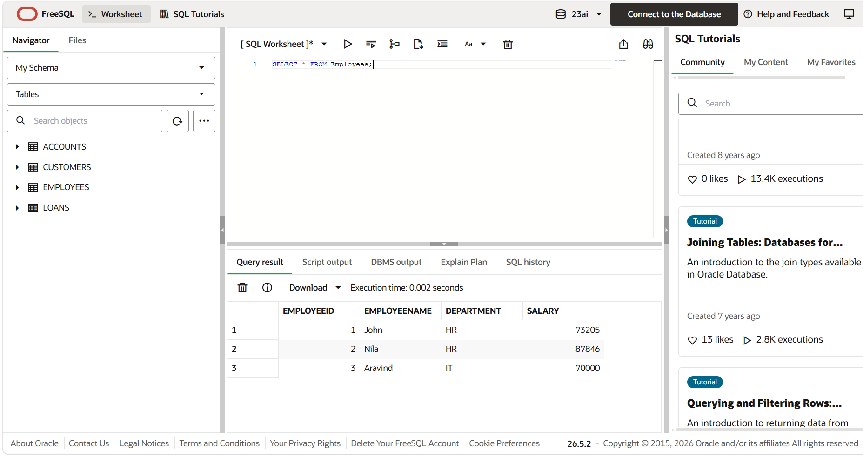

SCENARIO 3:
Customers should be able to transfer funds between their accounts.
CODE:
CREATE OR REPLACE PROCEDURE TransferFunds (
p_from_account IN NUMBER,
p_to_account IN NUMBER,
p_amount IN NUMBER
) IS
v_balance NUMBER;
BEGIN
SELECT Balance INTO v_balance
FROM Accounts
WHERE AccountID = p_from_account;
IF v_balance < p_amount THEN
RAISE_APPLICATION_ERROR(-20001, 'Insufficient balance in source account.');
END IF;
UPDATE Accounts
SET Balance = Balance - p_amount,
LastModified = SYSDATE
WHERE AccountID = p_from_account;
UPDATE Accounts
SET Balance = Balance + p_amount,
LastModified = SYSDATE
WHERE AccountID = p_to_account;
COMMIT;
END;
/
BEGIN
TransferFunds(1, 2, 300);
END;
SELECT AccountID, CustomerID, AccountType, Balance, LastModified
FROM Accounts
WHERE AccountID IN (1, 2);

OUTPUT:
